**NAME -** SHREYA BANSAL

**ROLL NO. –** 12012028

**BRANCH -** CS-A-02

**CO-PARTNER** - RITU YADAV

WEB DEVELOPMENT PROJECT

**Session**-

BTECH(1ST YEAR)(2ND SEMESTER)

**Submitted To** -

MISS DIVYA & MR VISHAL

**LITTLE HEARTS**

**NGO ……….(WEBSITE)…….**

…….. HOME PAGE ….….

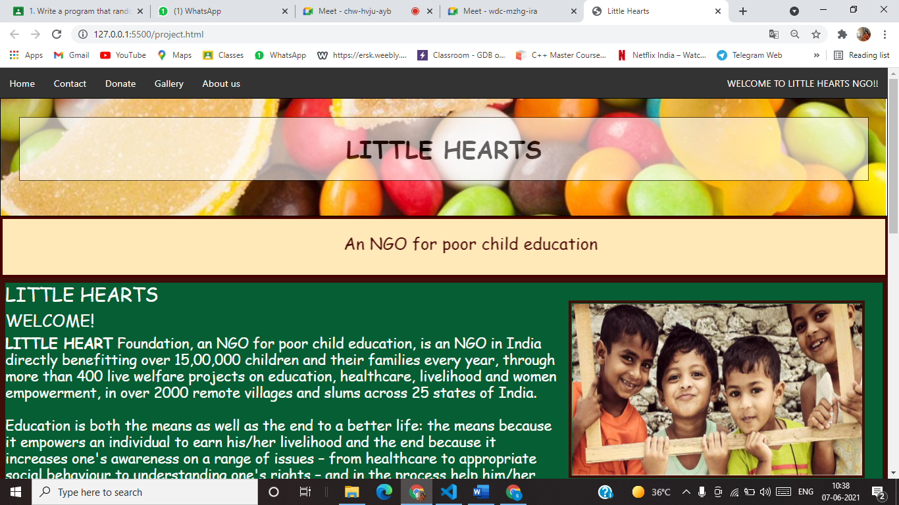

**\*NAVIGATION BAR\***

  <ul>

            <li><a href="project.html">Home</a></li>

            <li><a href="contact.html">Contact</a></li>

            <li><a href="donate.html">Donate</a></li>

            <li ><a class="active" href="gallery.html">Gallery</a></li>

            <li><a href="aboutus.html">About us</a></li>

            <li style="float:right"><a href ="project.html">WELCOME TO LITTLE HEARTS NGO!!</a></li>

          </ul>

**\*HEADING PART\***

 <div id="homeheading" >

        <div class="transbox">

            <h1>LITTLE HEARTS</h1>

          </div>

      </div>

      <div id="do">

          <br>

         <h3> <marquee >An NGO for poor child education </marquee></h3>

          <br>

      </div>

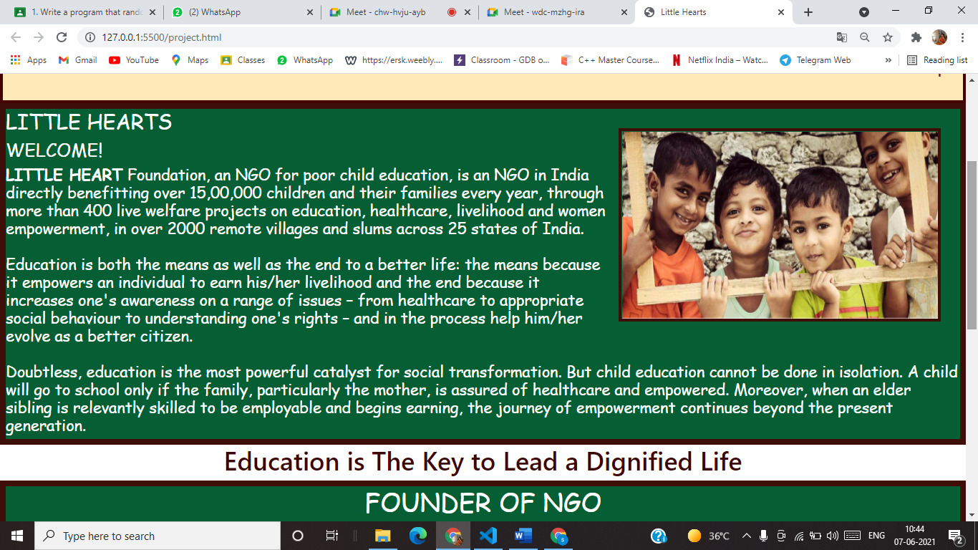

**\*INTRODUCTION\***

<div class="home">

        <img src="https://www.bailinson-oleary.com/wp-content/uploads/2019/08/Child-Support.jpg" id="child"style="width:500px;height:300px;margin-left:15px;">

              <h2>LITTLE HEARTS</h2>

              <h3>WELCOME!</h3>

              <h4>

               <strong> LITTLE HEART</strong> Foundation, an NGO for poor child education, is an NGO in India directly benefitting over 15,00,000 children and their families every year, through more than 400 live welfare projects on education, healthcare, livelihood and women empowerment, in over 2000 remote villages and slums across 25 states of India.<br><br>

                Education is both the means as well as the end to a better life: the means because it empowers an individual to earn his/her livelihood and the end because it increases one's awareness on a range of issues – from healthcare to appropriate social behaviour to understanding one's rights – and in the process help him/her evolve as a better citizen.<br><br>

                Doubtless, education is the most powerful catalyst for social transformation. But child education cannot be done in isolation. A child will go to school only if the family, particularly the mother, is assured of healthcare and empowered. Moreover, when an elder sibling is relevantly skilled to be employable and begins earning, the journey of empowerment continues beyond the present generation.

       </h4>

      </div>

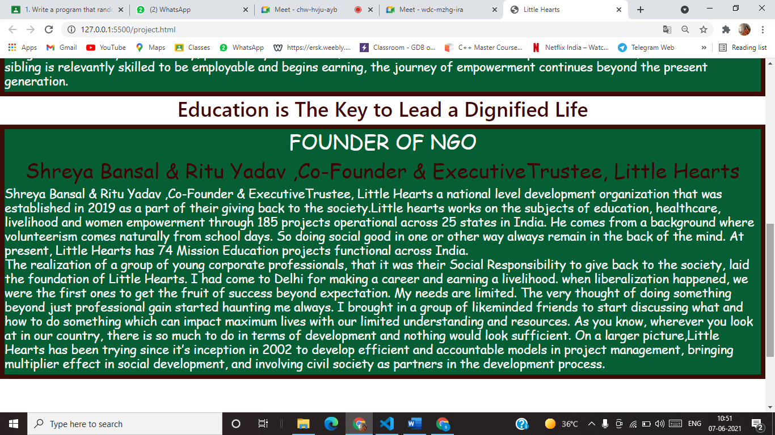

**\*FOUNDER OF NGO\***

<h5>Education is The Key to Lead a Dignified Life</h5>

      <div class="home">

       <h5 style="color: white;" > FOUNDER OF NGO </h5>

       <h5 style="text-align: center;">Shreya Bansal & Ritu Yadav ,Co-Founder & ExecutiveTrustee, Little Hearts</h5>

      <h4>

       Shreya Bansal & Ritu Yadav ,Co-Founder & ExecutiveTrustee, Little Hearts

       a national level development organization that was established in 2019  as a part of their giving back to the society.Little hearts  works on the subjects of education, healthcare, livelihood and women empowerment through 185 projects operational across 25 states in India. He comes from a background where volunteerism comes naturally from school days. So doing social good in one or other way always remain in the back of the mind. At present, Little Hearts has 74 Mission Education projects functional across India.

       <br>

       The realization of a group of young corporate professionals, that it was their Social Responsibility to give back to the society, laid the foundation of Little Hearts. I had come to Delhi for making a career and earning a livelihood.  when liberalization happened, we were the first ones to get the fruit of success beyond expectation. My needs are limited. The very thought of doing something beyond just professional gain started haunting me always. I brought in a group of likeminded friends to start discussing what and how to do something which can impact maximum lives with our limited understanding and resources. As you know, wherever you look at in our country, there is so much to do in terms of development and nothing would look sufficient.

On a larger picture,Little Hearts has been trying since it’s inception in 2002 to develop efficient and accountable models in project management, bringing multiplier effect in social development, and involving civil society as partners in the development process.

</h4>

      </div>

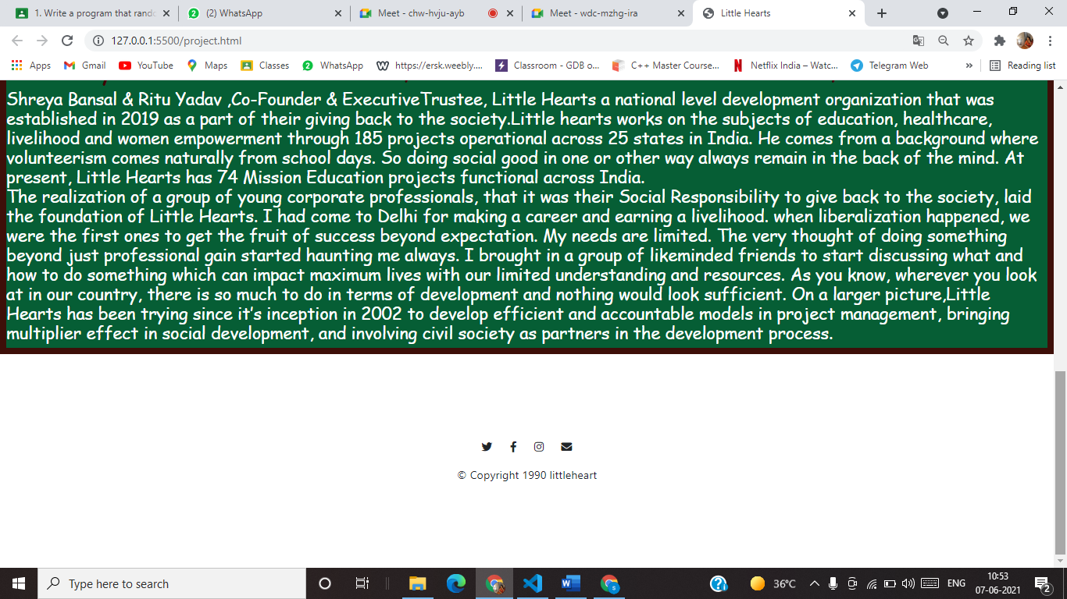

**\*FOOTER PART\***

 <footer id="footer">

        <i class="social-icon fab fa-twitter "></i>

        <i class="social-icon fab fa-facebook-f"></i>

        <i class="social-icon fab fa-instagram"></i>

        <i class="social-icon fas fa-envelope"></i>

        <p>© Copyright 1990 littleheart</p>

    </footer>

**………CONTACT PAGE……..**

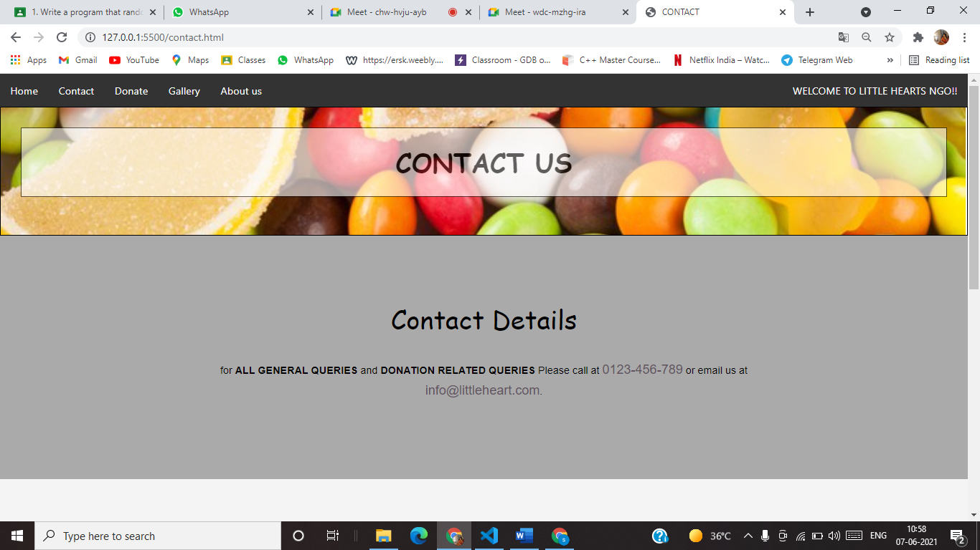

**\*CONTACT HEAD\***

<ul>

            <li><a href="project.html">Home</a></li>

            <li><a href="contact.html">Contact</a></li>

            <li><a href="donate.html">Donate</a></li>

            <li ><a class="active" href="gallery.html">Gallery</a></li>

            <li><a href="aboutus.html">About us</a></li>

            <li style="float:right"><a href ="project.html">WELCOME TO LITTLE HEARTS NGO!!</a></li>

          </ul>

        <section id="contact">

            <div id="homeheading" >

                <div class="transbox">

                    <h1>CONTACT US</h1>

                  </div>

              </div>

            <div class="contact-subheading">

                <h1>Contact Details</h1>

                <br>

                <p> for <strong>ALL GENERAL QUERIES</strong> and <strong>DONATION RELATED QUERIES</strong>  Please call at

                    <span>0123-456-789</span> or email us at <span>info@littleheart.com</span>.</p>

            </div>

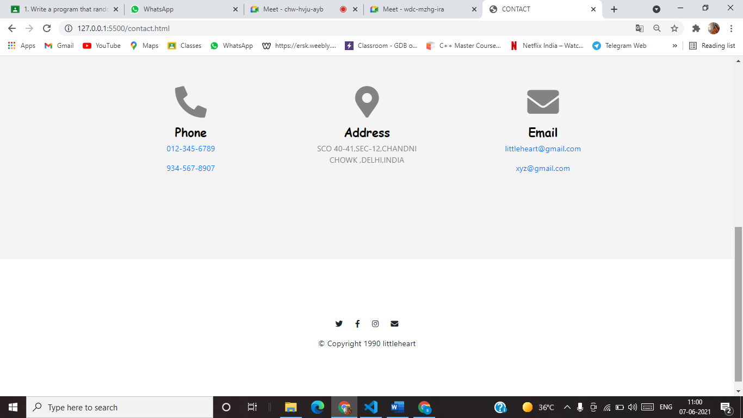

**\*CONTACT DETAILS\***

div class=" contact-icons">

                <div class="row">

                    <div class="col-lg-4 col-sm-4 contact-column">

                        <div class="item-contact">

                            <i class="icon fas fa-phone-alt fa-4x"></i>

                            <br>

                            <h4>Phone</h4>

                            <p><a href="tel:012-345-6789">012-345-6789</a></p>

                            <p><a href="tel:934-567-8907">934-567-8907</a></p>

                        </div>

                    </div>

                    <div class="col-lg-4 col-sm-4 contact-column">

                        <div class="item-contact">

                            <i class="icon fas fa-map-marker-alt fa-4x"></i>

                            <br>

                            <h4>Address</h4>

                            <p>SCO 40-41,SEC-12,CHANDNI CHOWK ,DELHI,INDIA </p>

                        </div>

                    </div>

                    <div class="col-lg-4 col-sm-4 contact-column">

                        <div class="item-contact">

                            <i class="icon fas fa-envelope fa-4x"></i>

                            <br>

                            <h4>Email</h4>

                            <p><a href="mailto:littleheart@gmail.com">littleheart@gmail.com </a></p>

                            <p><a href="mailto:xyz@gmail.com">xyz@gmail.com</a></p>

                        </div>

                    </div>

                </div>

            </div>

        </section>

        <footer id="footer">

            <i class="social-icon fab fa-twitter "></i>

            <i class="social-icon fab fa-facebook-f"></i>

            <i class="social-icon fab fa-instagram"></i>

            <i class="social-icon fas fa-envelope"></i>

            <p>© Copyright 1990 littleheart</p>

        </footer>

**………GALLERY GRID………….**

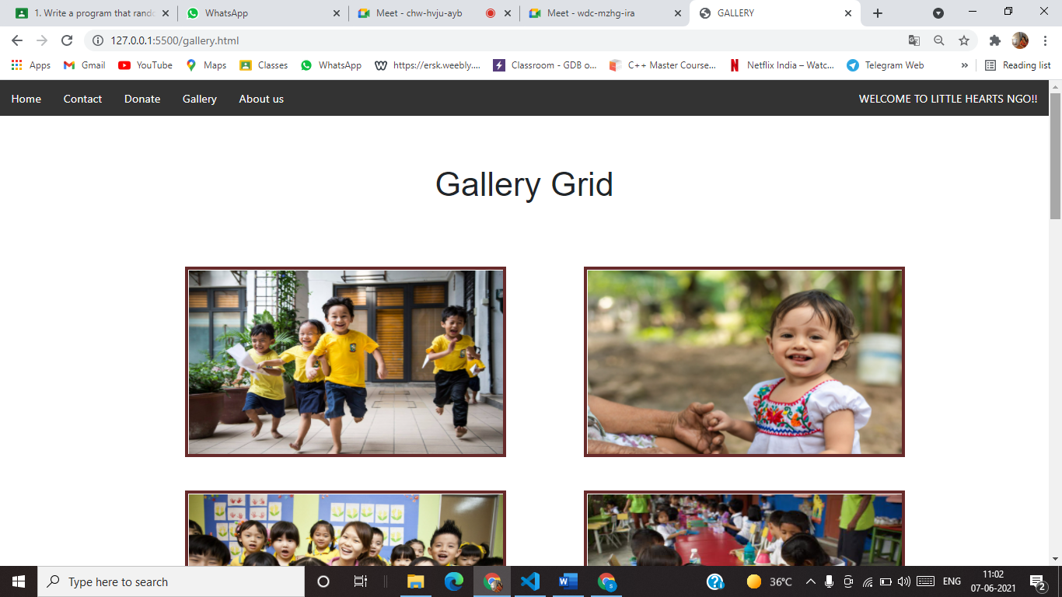

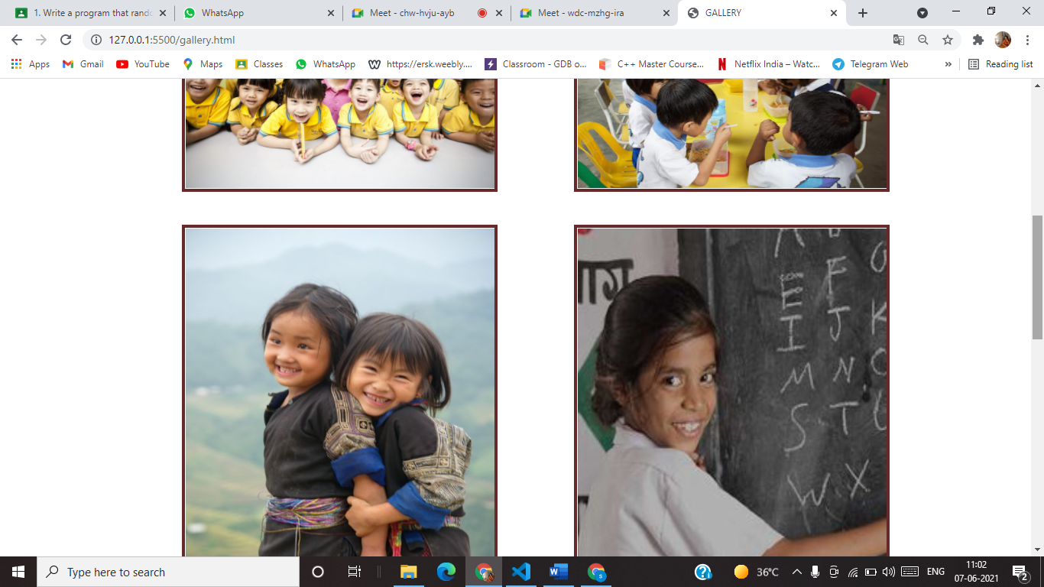

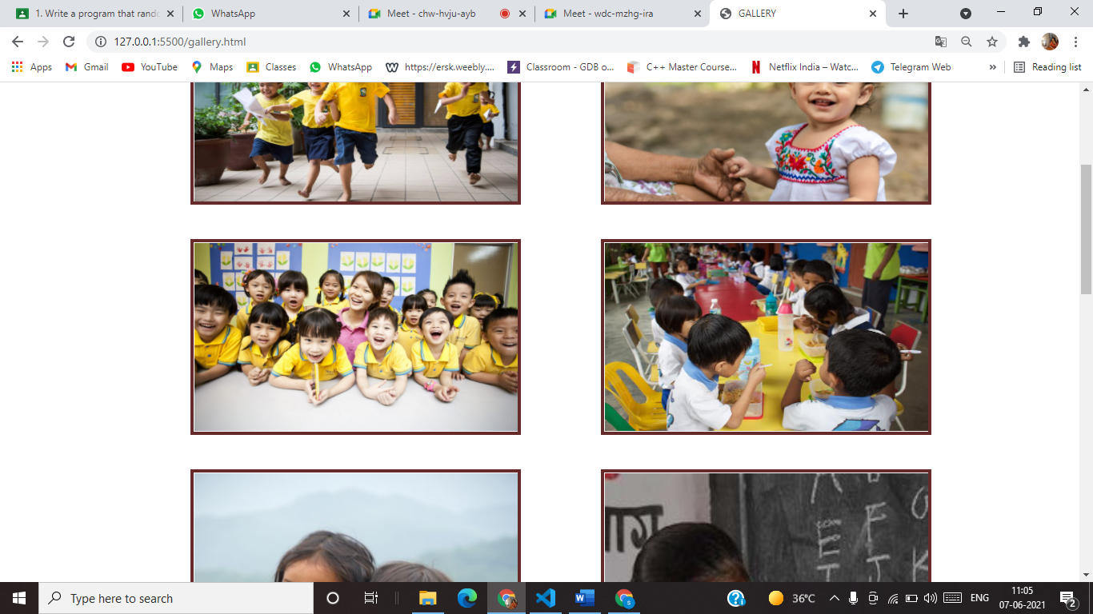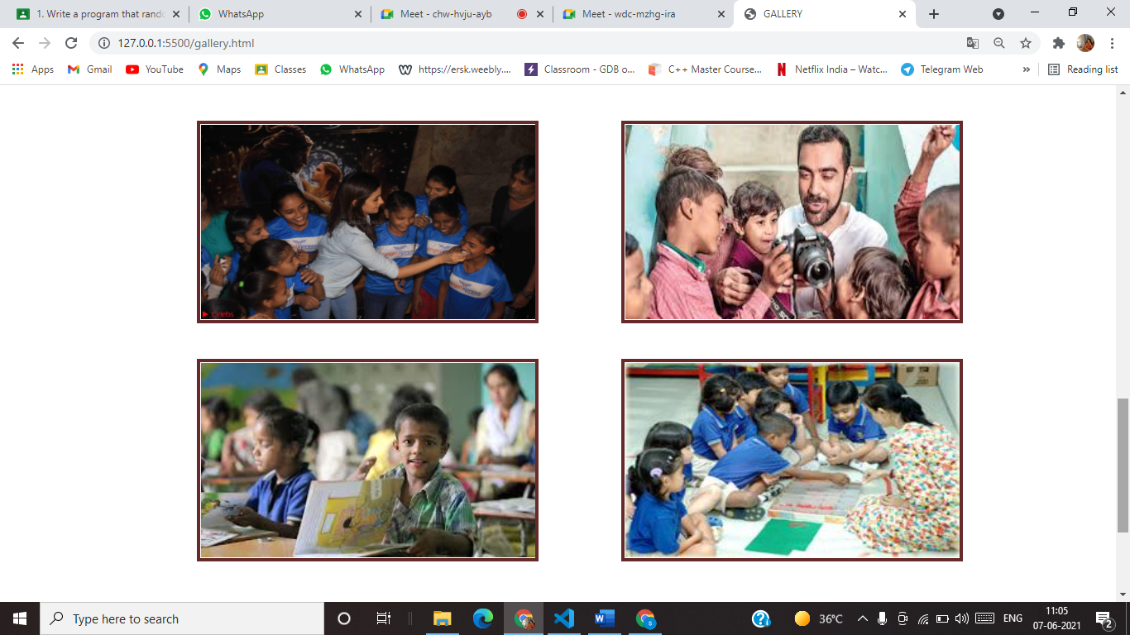

**\*Gallery Grid\***

 <ul>

            <li><a href="project.html">Home</a></li>

            <li><a href="contact.html">Contact</a></li>

            <li><a href="donate.html">Donate</a></li>

            <li ><a class="active" href="gallery.html">Gallery</a></li>

            <li><a href="aboutus.html">About us</a></li>

            <li style="float:right"><a href ="project.html">WELCOME TO LITTLE HEARTS NGO!!</a></li>

          </ul>

        <div class="container">

            <div class="gallery">

                <h2 class="gallery-heading">Gallery Grid</h2>

            </div>

        </div>

        <div class="container">

            <div class="row">

                <div class="col-lg-6 col-md-6">

                    <img class="gallery-img" src= "https://dignityforchildren.org/clients/asset_4B433D43-CF31-467D-882F-57272ECF8391/contentMS/img/thumb-dignity.jpg" >

                </div>

                <div class="col-lg-6 col-md-6">

                    <img class="gallery-img" src="https://www.zincsaveskids.org/wp-content/uploads/sites/21/2021/02/AdobeStock_314591503-scaled.jpeg"  >

                </div>

                <div class="col-lg-6 col-md-6">

                    <img class="gallery-img" src="https://starwayprofessional.com/wp-content/uploads/2018/06/IMG_5616_1aa-2000x1200.jpg" >

                </div>

                <div class="col-lg-6 col-md-6">

                    <img class="gallery-img" src="http://poskod.my/wp-content/uploads/2015/07/Rohingya-Refugee-Children-4-compressed.jpg" >

                </div>

                <div class="col-lg-6 col-md-6">

                    <img class="gallery-img" src="https://i.pinimg.com/originals/d7/99/69/d799698a1d49410cef5be1fc129aa479.jpg" >

                </div>

                <div class="col-lg-6 col-md-6">

                    <img class="gallery-img" src="https://i.pinimg.com/236x/0d/3e/f8/0d3ef882b82c95cb19d157190923e276.jpg" >

                </div>

                <div class="col-lg-6 col-md-6">

                    <img class="gallery-img" src="https://3.bp.blogspot.com/-i-hBQPJohaM/WMurSpfbACI/AAAAAAAAQyc/6c6FZmfpz4ctG-qvvm0nVFYAklVcjfMyACLcB/s1600/Alia+Bhatt+in+Denim+and+jeans+with+NGO+Kids+04.JPG">

                </div>

                <div class="col-lg-6 col-md-6">

                    <img class="gallery-img" src="https://encrypted-tbn0.gstatic.com/images?q=tbn:ANd9GcSTC9hHmCQO_NCBRybsoMPZh59nthMGa-MZfg&usqp=CAU" >

                </div>

                <div class="col-lg-6 col-md-6">

                    <img class="gallery-img" src="https://encrypted-tbn0.gstatic.com/images?q=tbn:ANd9GcTq0fW_lb4EoJ9MHI0SPHczRa2QL2LJBPPopQ&usqp=CAU" >

                </div>

                <div class="col-lg-6 col-md-6">

                    <img class="gallery-img" src="http://www.expat.com.my/images/Early%20Childhood%20Education%20Malaysia.jpg"  >

                </div>

            </div>

        </div>

        <footer id="footer">

            <i class="social-icon fab fa-twitter "></i>

            <i class="social-icon fab fa-facebook-f"></i>

            <i class="social-icon fab fa-instagram"></i>

            <i class="social-icon fas fa-envelope"></i>

            <p>© Copyright 1990 littleheart</p>

        </footer>

**……..About us Page………..**

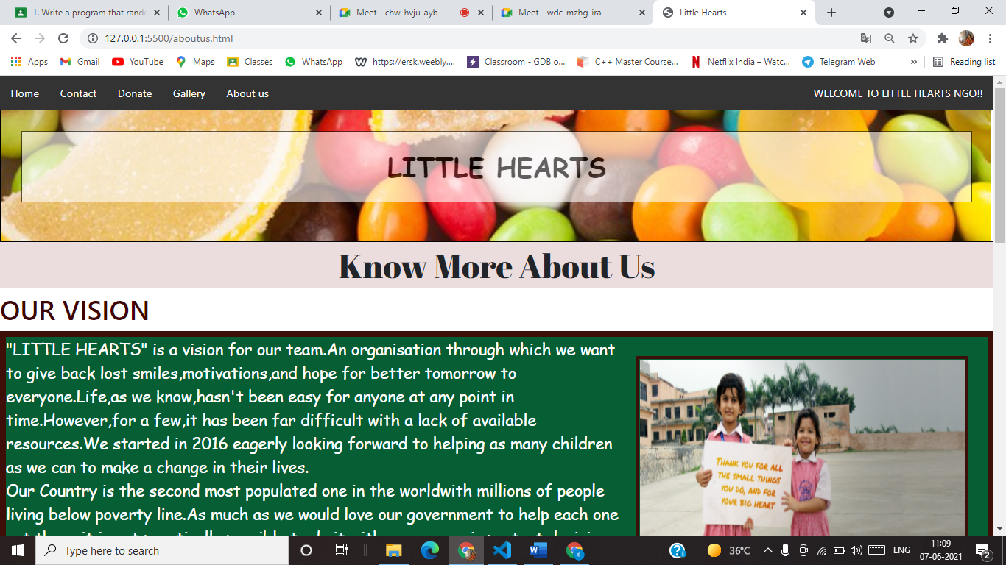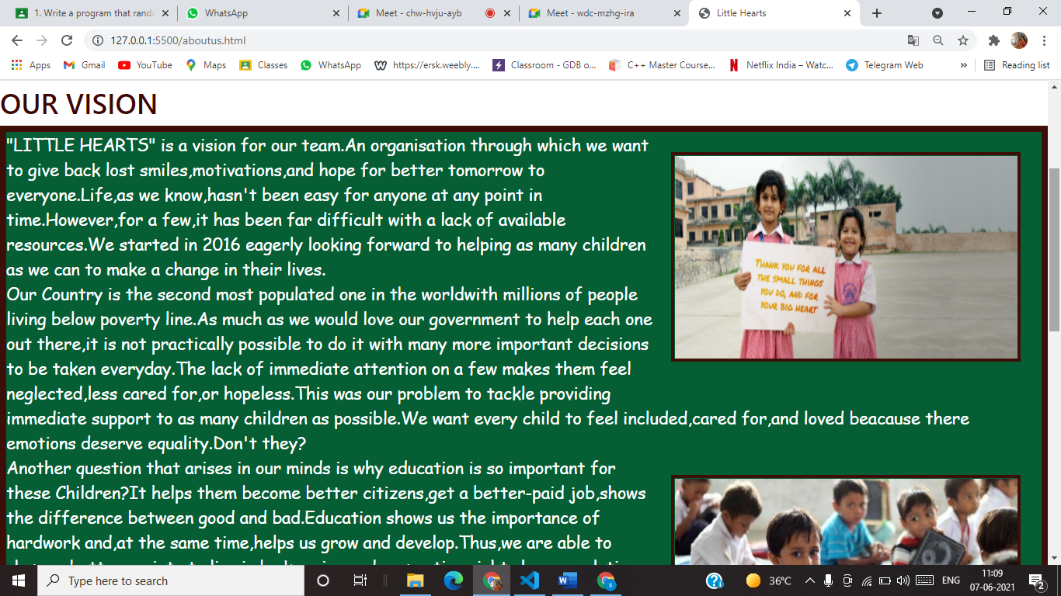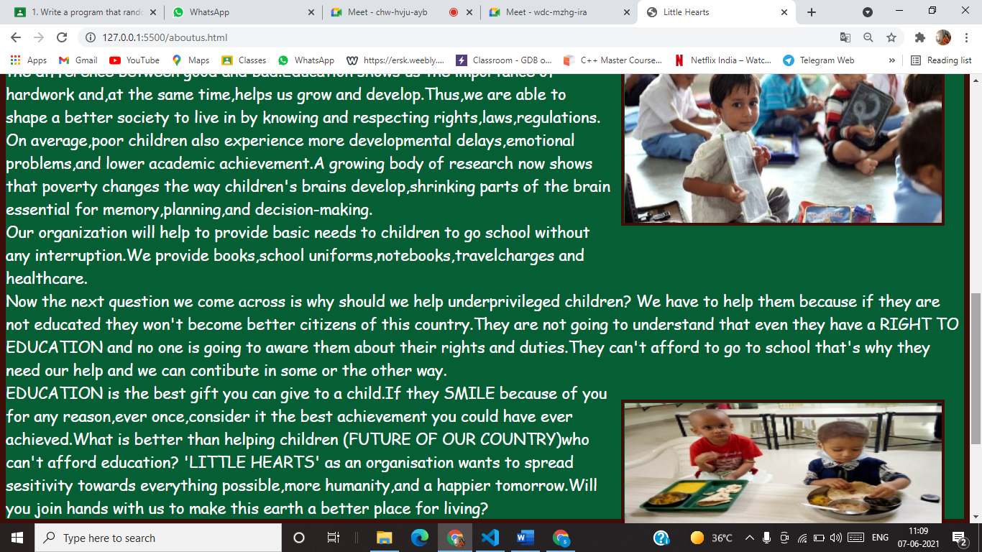

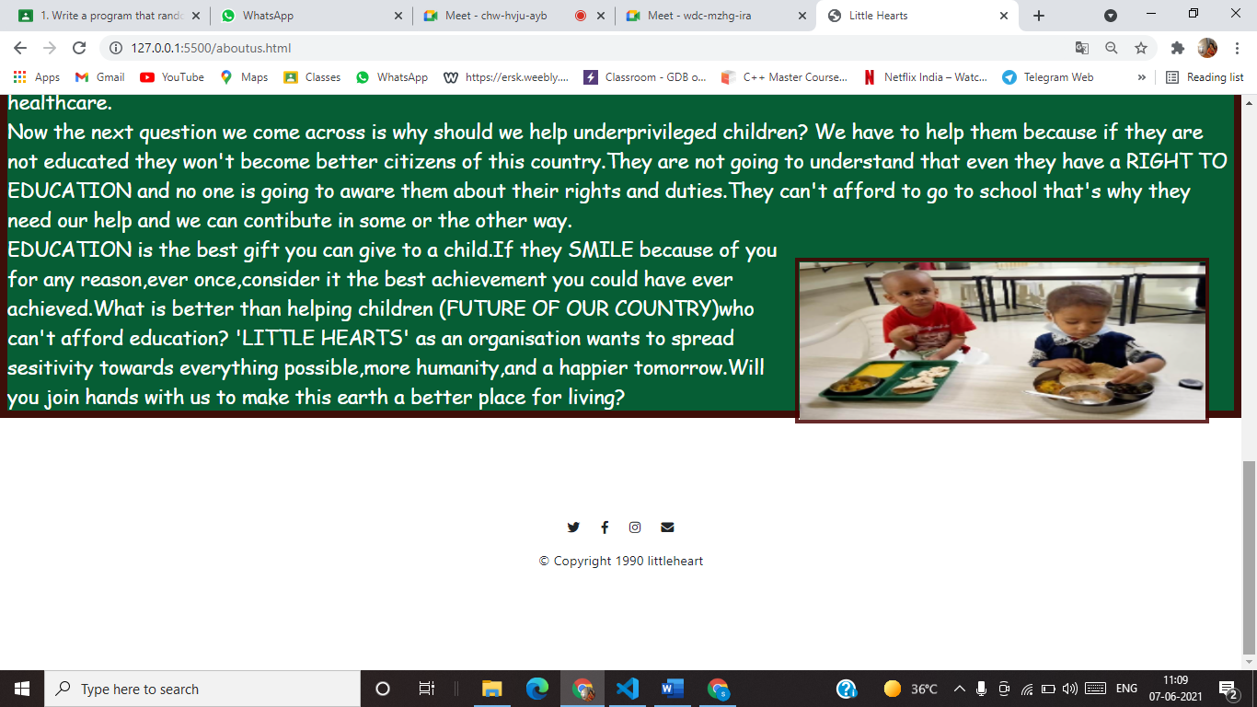

**\*KNOW ABOUT US\***

<style>

        h4{

            font-family:'Abril Fatface', 'Arial Narrow', Arial, sans-serif;

            text-align: center;

            font-size:50px;

            background-color:rgb(235, 221, 221);

            padding: 5px;

        }

        h5{

            text-align: left;

            font-size: 40px;

            color:rgb(63, 4, 4);

        }

        .About{

            color:rgb(255,255,255);

            border:9px solid rgba(73,0,0,0.836);

            background-color: rgb(6,94,53);

            font-family:'grandstander',cursive;

            font-size:x-large;

        }

    </style>

    </head>

    <body >

    <ul>

        <li><a href="project.html">Home</a></li>

        <li><a href="contact.html">Contact</a></li>

        <li><a href="donate.html">Donate</a></li>

        <li ><a class="active" href="gallery.html">Gallery</a></li>

        <li><a href="aboutus.html">About us</a></li>

        <li style="float:right"><a href ="project.html">WELCOME TO LITTLE HEARTS NGO!!</a></li>

      </ul>

      <div id="homeheading" >

        <div class="transbox">

            <h1>LITTLE HEARTS</h1>

          </div>

      </div>

      <h4>Know More About Us</h4>

      <h5>OUR VISION</h5>

      <div class="About">

        <img src="https://www.daughterofmoon.com/images/new-imagesnew1/banner-slider1.jpg" id="child" style="width:500px;height:300px;margin-left:15px;">

      "LITTLE HEARTS" is a vision for our team.An organisation through which we want to give back lost smiles,motivations,and hope for better tomorrow to everyone.Life,as we know,hasn't been easy for anyone at any point in time.However,for a few,it has been far difficult with a lack of available resources.We started in 2016 eagerly looking forward to helping as many children as we can to make a change in their lives.

     </br>

      Our Country is the second most populated one in the worldwith millions of people living below poverty line.As much as we would love our government to help each one out there,it is not practically possible to do it with many more important decisions to be taken everyday.The lack of immediate attention on a few makes them feel neglected,less cared for,or hopeless.This was our problem to tackle providing immediate support to as many children as possible.We want every child to feel included,cared for,and loved beacause there emotions deserve equality.Don't they? </br>

      <img src="https://qph.fs.quoracdn.net/main-qimg-1450ac7bbd49dca841f0fcb32492828d"style="width:500px;height:300px;margin-left:15px;">

      Another question that arises in our minds is why education is so important for these Children?It helps them become better citizens,get a better-paid job,shows the difference between good and bad.Education shows us the importance of hardwork and,at the same time,helps us grow and develop.Thus,we are able to shape a better society to live in by knowing and respecting rights,laws,regulations.</br>

      On average,poor children also experience more developmental delays,emotional problems,and lower academic achievement.A growing body of research now shows that poverty changes the way children's brains develop,shrinking parts of the brain essential for memory,planning,and decision-making.</br>

      Our organization will help to provide basic needs to children to go school without any interruption.We provide books,school uniforms,notebooks,travelcharges and healthcare.

    </br>

    Now the next question we come across is why should we help underprivileged children?

    We have to help them because if they are not educated they won't become better citizens of this country.They are not going to understand that even they have a RIGHT TO EDUCATION and no one is going to aware them about their rights and duties.They can't afford to go to school that's why they need our help and we can contibute in some or the other way.</br>

     <img src="https://cdn.givind.org/static/images/update/2019-11-11-jaipurchildrenenjoyingfood1-revathyjayakumar.jpeg" id="child" style="width:500px;height:200px;margin-left:15px;">

      EDUCATION is the best gift you can give to a child.If they SMILE because of you for any reason,ever once,consider it the best achievement you could have ever achieved.What is better than helping children (FUTURE OF OUR COUNTRY)who can't afford education? 'LITTLE HEARTS' as an organisation wants to spread sesitivity towards everything possible,more humanity,and a happier tomorrow.Will you join hands with us to make this earth a better place for living?

</div>

      <footer id="footer">

        <i class="social-icon fab fa-twitter "></i>

        <i class="social-icon fab fa-facebook-f"></i>

        <i class="social-icon fab fa-instagram"></i>

        <i class="social-icon fas fa-envelope"></i>

        <p>© Copyright 1990 littleheart</p>

    </footer>

**………DONATE PAGE……….**

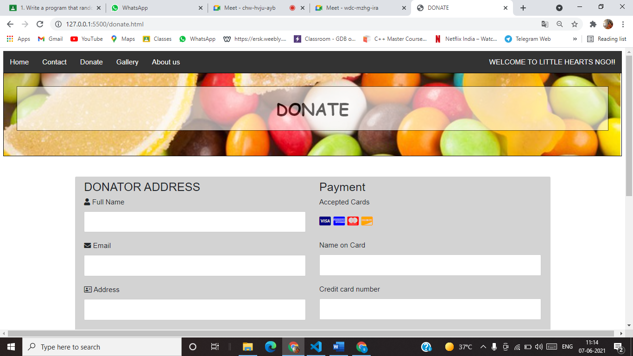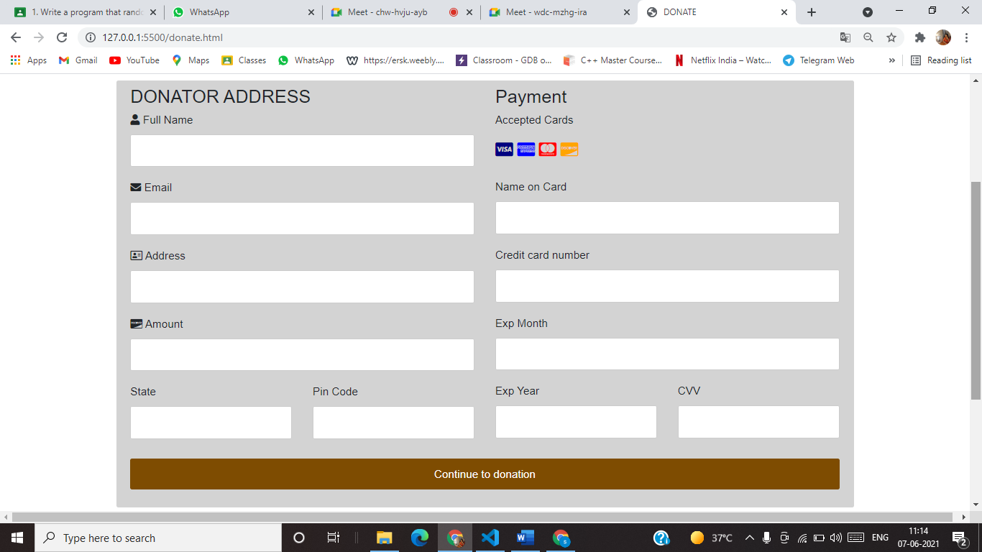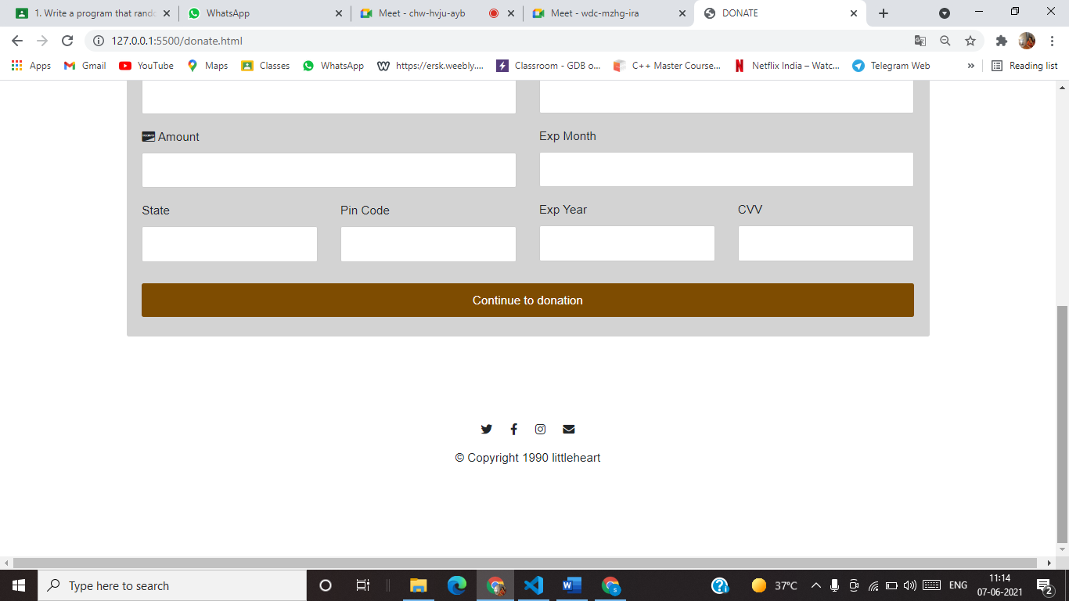

**\*DONATE\***

  <style>

            body {

              font-family: Arial;

              font-size: 17px;

              padding: 8px;

            }

            * {

              box-sizing: border-box;

            }

            .row {

              display: -ms-flexbox; /* IE10 */

              display: flex;

              -ms-flex-wrap: wrap; /* IE10 */

              flex-wrap: wrap;

              margin: 0 -16px;

            }

            .col-25 {

              -ms-flex: 25%; /* IE10 */

              flex: 25%;

            }

            .col-50 {

              -ms-flex: 50%; /* IE10 */

              flex: 50%;

            }

            .col-75 {

              -ms-flex: 75%; /* IE10 */

              flex: 75%;

            }

            .col-25,

            .col-50,

            .col-75 {

              padding: 0 16px;

            }

            .container {

              background-color: lightgrey;

              padding: 5px 20px 15px 20px;

              border: 2px solid rgba(211, 211, 211, 0.308);

              border-radius: 3px;

            }

            input[type=text] {

              width: 100%;

              margin-bottom: 20px;

              padding: 12px;

              border: 1px solid #ccc;

              border-radius: 3px;

            }

            label {

              margin-bottom: 10px;

              display: block;

            }

            .icon-container {

              margin-bottom: 20px;

              padding: 7px 0;

              font-size: 24px;

            }

            .btn {

              background-color: #7e4c01;

              color: white;

              padding: 12px;

              margin: 10px 0;

              border: none;

              width: 100%;

              border-radius: 3px;

              cursor: pointer;

              font-size: 17px;

            }

            .btn:hover {

              background-color: #251400;

            }

            a {

              color: #2196F3;

            }

            hr {

              border: 1px solid rgb(255, 235, 119);

            }

            /* Responsive layout - when the screen is less than 800px wide, make the two columns stack on top of each other instead of next to each other (also change the direction - make the "cart" column go on top) */

            @media (max-width: 800px) {

              .row {

                flex-direction: column-reverse;

              }

              .col-25 {

                margin-bottom: 20px;

              }

            }

            </style>

        <script src="https://kit.fontawesome.com/cdad65c924.js" crossorigin="anonymous"></script>

        <title>DONATE</title>

    </head>

    <body >

      <ul>

        <li><a href="project.html">Home</a></li>

        <li><a href="contact.html">Contact</a></li>

        <li><a href="donate.html">Donate</a></li>

        <li ><a class="active" href="gallery.html">Gallery</a></li>

        <li><a href="aboutus.html">About us</a></li>

        <li style="float:right"><a href ="project.html">WELCOME TO LITTLE HEARTS NGO!!</a></li>

      </ul>

        <section id="contact">

            <div id="homeheading" >

                <div class="transbox">

                    <h1>DONATE</h1>

                  </div>

              </div>

            </section>

            <br>

            <br>

               <script>

              function msg(){

                 var x , text;

                  // Get the value of the input field with id="numb"

            x = document.getElementById("Amount").value;

             // Get the value of the input field with id="numb"

             text = document.getElementById("fullname").value;

            document.write("&nbsp&nbsp&nbsp&nbsp&nbsp&nbsp&nbsp&nbsp&nbsp&nbsp");

             document.write("&nbsp&nbsp&nbsp&nbsp&nbsp&nbsp&nbsp&nbsp&nbsp&nbsp");

             document.write("&nbsp&nbsp&nbsp&nbsp&nbsp&nbsp&nbsp&nbsp&nbsp&nbsp");

             document.write("&nbsp&nbsp&nbsp&nbsp&nbsp&nbsp&nbsp&nbsp&nbsp&nbsp");

             document.write("&nbsp&nbsp&nbsp&nbsp&nbsp&nbsp&nbsp&nbsp&nbsp&nbsp");

             document.write("&nbsp&nbsp&nbsp&nbsp&nbsp&nbsp&nbsp&nbsp&nbsp&nbsp");

             document.write("&nbsp&nbsp&nbsp&nbsp&nbsp&nbsp&nbsp&nbsp&nbsp&nbsp");

             document.write("&nbsp&nbsp&nbsp&nbsp&nbsp&nbsp&nbsp&nbsp&nbsp&nbsp");

             document.write("&nbsp&nbsp&nbsp&nbsp&nbsp&nbsp&nbsp&nbsp&nbsp&nbsp");

             document.write("&nbsp&nbsp&nbsp&nbsp&nbsp&nbsp&nbsp&nbsp&nbsp&nbspThank you!! ");

             document.writeln(text);

             document.write(" , Your transaction is done completely .");

             document.write("<br><br>&nbsp&nbsp&nbsp&nbsp&nbsp&nbsp&nbsp&nbsp&nbsp&nbsp");

             document.write("&nbsp&nbsp&nbsp&nbsp&nbsp&nbsp&nbsp&nbsp&nbsp&nbsp");

             document.write("&nbsp&nbsp&nbsp&nbsp&nbsp&nbsp&nbsp&nbsp&nbsp&nbsp");

             document.write("&nbsp&nbsp&nbsp&nbsp&nbsp&nbsp&nbsp&nbsp&nbsp&nbsp");

             document.write("&nbsp&nbsp&nbsp&nbsp&nbsp&nbsp&nbsp&nbsp&nbsp&nbsp");

             document.write("&nbsp&nbsp&nbsp&nbsp&nbsp&nbsp&nbsp&nbsp&nbsp&nbsp");

             document.write("&nbsp&nbsp&nbsp&nbsp&nbsp&nbsp&nbsp&nbsp&nbsp&nbsp");

             document.write("&nbsp&nbsp&nbsp&nbsp&nbsp&nbsp&nbsp&nbsp&nbsp&nbsp");

             document.write("&nbsp&nbsp&nbsp&nbsp&nbsp&nbsp&nbsp&nbsp&nbsp&nbsp");

             document.write("&nbsp&nbsp&nbsp&nbsp&nbsp&nbsp&nbsp&nbsp&nbsp&nbsp");

             document.write("&nbsp&nbsp&nbsp&nbsp&nbsp&nbsp&nbsp&nbsp&nbsp&nbsp");

             document.writeln(x);

              document.write(" is successfully added to our account .");

                 }

               </script>

            <div class="row">

                <div class="col-75">

                  <div class="container">

                    <form >

                      <div class="row">

                        <div class="col-50">

                          <h3>DONATOR ADDRESS</h3>

                          <label for="fname"><i class="fa fa-user"></i> Full Name</label>

                          <input type="text" id="fullname" name="name" >

                          <label for="email"><i class="fa fa-envelope"></i> Email</label>

                          <input type="text" id="email" name="email">

                          <label for="adr"><i class="fa fa-address-card-o"></i> Address</label>

                          <input type="text" id="adr" name="address" >

                          <label for="Amount"><i class="fa fa-cc-discover"></i> Amount</label>

                          <input type="text" id="Amount" name="Amount" >

                          <div class="row">

                            <div class="col-50">

                              <label for="state">State</label>

                              <input type="text" id="state" name="state" >

                            </div>

                            <div class="col-50">

                              <label for="zip">Pin Code</label>

                              <input type="text" id="zip" name="zip" >

                            </div>

                          </div>

                        </div>

                        <div class="col-50">

                          <h3>Payment</h3>

                          <label for="fname">Accepted Cards</label>

                          <div class="icon-container">

                            <i class="fa fa-cc-visa" style="color:navy;"></i>

                            <i class="fa fa-cc-amex" style="color:blue;"></i>

                            <i class="fa fa-cc-mastercard" style="color:red;"></i>

                            <i class="fa fa-cc-discover" style="color:orange;"></i>

                          </div>

                          <label for="cname">Name on Card</label>

                          <input type="text" id="cname" name="cardname" >

                          <label for="ccnum">Credit card number</label>

                          <input type="text" id="ccnum" name="cardnumber" >

                          <label for="expmonth">Exp Month</label>

                          <input type="text" id="expmonth" name="expmonth" >

                          <div class="row">

                            <div class="col-50">

                              <label for="expyear">Exp Year</label>

                              <input type="text" id="expyear" name="expyear">

                            </div>

                            <div class="col-50">

                              <label for="cvv">CVV</label>

                              <input type="text" id="cvv" name="cvv" >

                            </div>

                          </div>

                        </div>

                      </div>

                      <script>

                      //  function msg()

                       // {

                       //   alert("Thank You!! Your transaction is done");

                       // }

                      </script>

                      <input type="submit" id= "x" value="Continue to donation" class="btn" onclick="msg()" value="call function"/>

                    </form>

                  </div>

                </div>

                </div>

            <footer id="footer">

                <i class="social-icon fab fa-twitter "></i>

                <i class="social-icon fab fa-facebook-f"></i>

                <i class="social-icon fab fa-instagram"></i>

                <i class="social-icon fas fa-envelope"></i>

                <p>© Copyright 1990 littleheart</p>

            </footer>

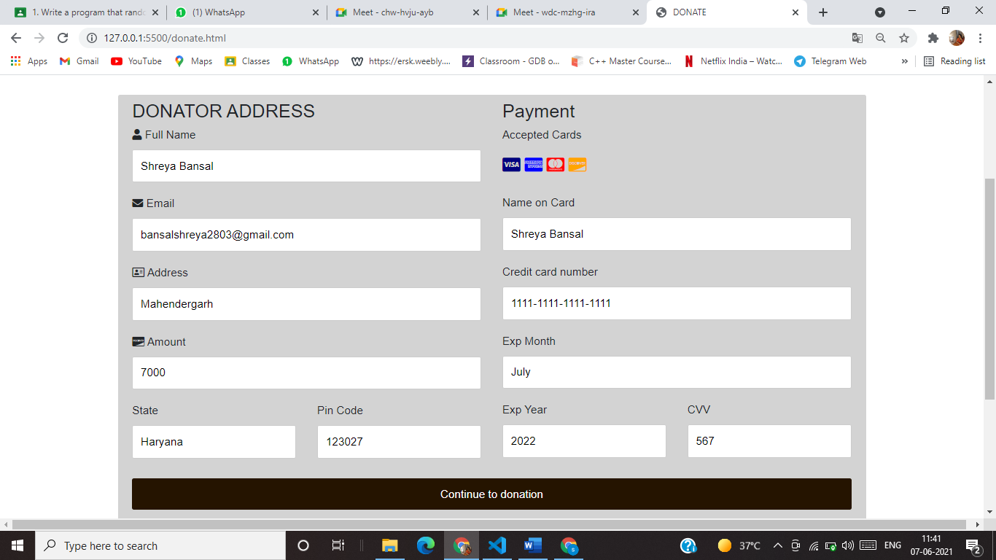

**After filling donation form details and go on continue to donation…….**

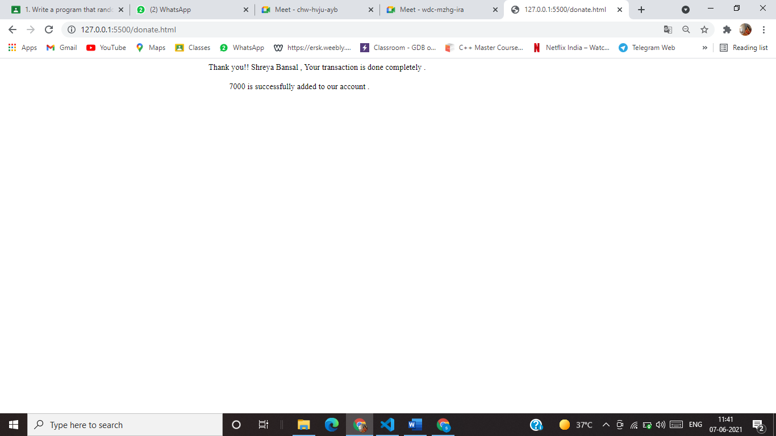

**\*\*\*\*\*\*\*\*\*\*\*\*\*THANK YOU\*\*\*\*\*\*\*\*\*\*\*\*\*\*\*\***